20.45: There are many equivalent ways of finding the efficiency; the method presented here saves some steps. The temperature at point 3 is 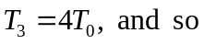
where 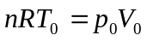has been used for an ideal gas. The work done by the gas during one cycle is the area enclosed by the blue square in Fig. (20.22), 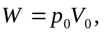and so the efficiency is 